**GROUP DOCUMENTATION**

**COURSE CODE: CT049-3-1-OSCA-T-23**



**TECHNOLOGY PARK MALAYSIA**

**OPERATING SYSTEM AND COMPUTER ARCHITECTURE**

SUBMITTED BY

|  |  |
| --- | --- |
| Tsang Da Xin | TP071168 |
| Patrick Woo Soon Tat | TP070151 |
| Tan Yen Hau | TP071849 |
| Ebenezer Paul A/L Vilsan Paul | TP071690 |
| Vasshan Raj A/L Ganesan | TP070649 |
| Anantha Krisnan A/L Thiru Kumar | TP072208 |

STUDENT OF COMPUTER SCIENCE IN

APU1F2309CS

COMPUTING AND TECHNOLOGY

SUBMITTED TO

Mr. Abu Bakar S. Santuraki

School of Technology, Network, Security, Forensics

PROPOSAL HAND OUT: WEEK 2 / SUBMISSION DUE DATE:22/12/2024

# Abstract

PlayStation 5 has marked significant technological advancements in console gaming technology after the success of PS4. It redefines many consoles’ player's gaming experience with its robust and versatile operating system, hardware, and software features.

Sony’s journey that focuses on the gaming sector is with the first PlayStation. Over decades, gaming platforms have evolved through PS2, PS3 and PS5. Each model pushes boundaries in gaming technology and can captivate more customers across the globe.

With every release, Sony refined its console by continuously improving graphics, enhancing the gameplay experience, and adapting to current trends in gaming. On November 12th, 2020, PS5 was released and redefining what’s possible for a gaming console by incorporating cutting-edge features.

PS5 console utilizes a custom-designed operating system that is engineered for speed and efficiency and allows swift access to games and applications. Not only that, but its system ensures rapid loading times and multitasking capabilities. Therefore, this project is conducted to explore and research about the hardware and software elements of the PlayStation 5 (PS5) specially focusing on Computer Architecture and the Operating System. Besides that, this report will cover its user interface design efficiency of its file management systems and security and protection services and that shape the gaming landscape of PS5’s console.

At its core, PS5 integrates a high-performance custom CPU and GPU that optimize gaming experiences with advanced hardware such as ray tracing, high frame rates, and stunning visuals. This report will provide a comprehensive overview of PS5’s hardware, which will emphasize its specification, description which will include its advantages and drawbacks, and its overall rating based on marketplace user’s ratings.

Table of Contents

Part A: Introduction 4

1.0 Introduction to company/operating systems 4

1.1 Overview of PS5 console 4

1.2 History of Sony / PlayStation Console 4

2.0 People who are involved in the creation of devices / OS 11

3.0 Sales & statistics about Sony’s PlayStation 5 15

3.1 Features of PlayStation 5 15

3.2 Accessories of PlayStation 5 16

3.3 Fun facts about PlayStation 5 16

4.0 Hardware 17

4.1 Introduction to hardware function and capabilities 17

CPU 17

System memory 18

Cooling system 20

5.0 Operating System 31

5.1 Introduction 31

5.2 User Interface 32

5.3 File management operating system 34

7.0 References 40

8.0 Appendices 43

8.1 Work breakdown structure 43

8.2 Minutes of Meeting 45

8.3 Frequently asked question 47

8.4 Gantt chart 49

# Part A: Introduction

## Introduction to company/operating systems

## 1.1 Overview of PS5 console

Sony’s PlayStation 5 is out now in worldwide market it was launched back on November 12, 2020, in Australia, Japan, North America, Korea, and New Zealand. As for countries such as China, Indonesia, India, etc., it was released worldwide several days later, on November 19. Back then on April 16, 2019, system architect Mark Cerny revealed that his team had been working on a successor to PS5 in an interview with Wired. PlayStation 5 console has few significant improvements over PlayStation4 which consists of an improved CPU (Ryzen chip and 7nm octa-core third generation), ray tracing support, custom 3D audio chip, and SSD (instead of HDD) that is compatible with PlayStation VR headsets.

## 1.2 History of Sony / PlayStation Console

During World War II, in 1946, Masaru Ibuka started an electronic shop in Tokyo with $1400 in capital and eight employees. Then he was joined by his colleague, Akio Morita who shared the same belief as Masaru as they believed if they worked together, they could make ideas a reality. The company was initially called Tokyo Tsushin Kogyo and in the early 1950s, it produced its first tape recorder known as Type-G. The company’s name was then renamed Sony (a combination of two words:” Sonus,” the Latin word for sound, and “sonny,” representing a young boy or small son in 1958.

Given the popularity of their products, Co-founder Akio Morita set up and headed to an American company and set about ensuring that the name Sony gained a great reputation. Due to the high quality of Sony’s products, Americans began to see products manufactured in Japan in a better light. Because of that, the company could hold tight to their higher price compared to other products in the marketplace. In the year 1968, Sony’s Trinitron color television was introduced and was a breakthrough in the display technology sector which featured a flat-screen and advanced color reproduction. Due to this, Sony has set new standards in the TV industry and established Sony as a leader in consumer electronics. In the year 1971, Ibuka stood down as president and handled the position over to his co-founder Morita and Sony broke into the life insurance market in 1979.

In the year 1979, that’s when the well-known Walkman (TPS-L2) was launched, and it transformed how people experienced music. The initial idea why Walkman was created was because Akio Morita wanted to be able to listen to music while on long flights. Walkman is a portable cassette player that allows users to walk while carrying their music. Sony has also entered both the entertainment and music industry. This led to the formation of Sony Pictures Entertainment and control over a vast catalog of artists and tracks in the music industry.

In the late 1980s, Sony began collaborating with Nintendo on a CD-ROM add-on for Super Nintendo Entertainment System. However, the collaboration failed, and Sony decided to market its console which led to the development of PlayStation.

On December 3rd, 1994. Sony has decided to release a console called “PlayStation” which sells for $299 on release. It was a huge success as it sold over 36 million units and it was out of expectations to the point that players were lining up outside stores and retailers ruining out-of-stock daily. From this moment, it was the official start of the PlayStation lineup. Many third-party developers would switch from companies such as Nintendo and Sega and move towards Sony due to its popularity and technical capabilities as the storage capacity of CD-ROM gives them more options for the creation of the console game. Some franchises found success on PlayStation, some titles stood out from each other for example, Final Fantasy VII, which helps to sell the console at an even greater rate and its flashy marketing combined with graphics turn kids and adults into RPG gamers for the first time.

On March 4th,2000, Sony released the successor to PlayStation which is known as PS2. PlayStation2 offered the ability to play over the internet and play with DVDs, which led to its sales dominance over its 64-bit rivals Sega Dreamcast and Nintendo GameCube. Due to the many great gaming experiences the original PlayStation offered, it has established a strong fan base and within days, the console has passed into millions of sales figures. Sony ensured that PS2 is backward compatible which provides greater experiences for players through sequels and fresh titles for all their most beloved franchises. Not only that, but the console also has memory cards (save file holders) with greater storage capacity to handle larger and more complex games than other well-known franchises offer. On July 7th, 2000, Sony launched a new model of the original PlayStation called “PS One” and on November 25th, 2004, Sony released the PS2 Slim which is a smaller version of PS2.

On November 11th, 2006, Sony released PlayStation 3. It was released with one edition with a 20 GB storage capacity and another one with a 60 GB version. For 20GB versions was not only possessed lesser storage capacity, but it also lacked the HDMI port, flash drive reader, and WI-FI internet connectivity 60GB version. The first PS3 models could read both PS2 and PS1 discs and play games. The console has moved from DVDs to larger storage capacity and technical capabilities of Blu-Ray discs, which allows developers from different franchises to have greater space to come out with more innovative and creative worlds and stories. Fun facts, PS3 was the first Sony console to have a wireless controller and allowed players to set flagstones during their game journey through stages of collecting trophies and points by utilizing the Internet. Players can purchase games digitally and store them on their console’s hard drive through the PlayStation store. Even though the PS3 was a flop with a minimum of $499 as it didn’t sell as much anywhere as the previous console, Sony managed to offer players some unforgettable and incredible experiences for their fanbase. On September 1st, 2009, Sony released both the PS3 Slim and Super Slim on September 25th, 2012, which was not only slimmer but also much cheaper. However, the PS3 Slim was not much of a success because it consisted of few ports and didn’t feature the ability to play PS2 games and storage was limited.

On November 15th, 2013, Sony released PlayStation 4 and it was a huge success. Since the release of PS3, Sony has been brainstorming on a console that would give developers greater creative freedom for their consumers. PS4 entered the development phase in 2008 and has built up rumors for the release of the new console. This time PS4 was much superior to its competitor, Xbox One by selling at a cheaper price of $399 compared to Xbox One which cost $499 by outselling it almost 3 to 1.

The reason why PS4 outsells Xbox is largely due to its impressive launch titles of the console and Sony is incredibly good at utilizing their marketing strategy to target the right consumers. In addition, the console itself has some non-gaming aspects which include the integration of cable smart TV and basic voice control. Speaking of user experience, PS4 featured a range of options for them to interact, for example, the ability to create social groups based on their user interests and able to form parties so they can play together via communicating in a headset. Pursuing this further, the new controller featured a “Share” button that allows players to share their achievements or images of their in-game adventures and live-stream their games or watch other players from across the globe who play their favorite titles on social media accounts. Users can leave comments or likes on it.

As PlayStation has already established grounded well-known franchises, PS4 became a solid foundation for many up-and-coming independent studios to come out with their work. Because of that, PS4 is well-known for its incredible gaming experiences as it offers stunning visual effects and soundtracks. On September 16th, 2016, PS4 Slim was released as a lighter console compared to the previous ones and much cheaper. On November 10th, 2016, PS4 Pro was released with much better specs and the ability to play video games at 4k 30 fps with 1TB options along with a better cooling system.

On November 12th, 2020, PS5 was released and was represented as a major set-up in the technology sector. PS5 has two variants, both featuring the same horsepower and SSD of 825. However, the standard model comes with a 4k Blu-Ray disc at the price of $499 while the $399 version only relies on digital downloads as it lacks a physical disc drive. Sony has manufactured PS5 with big updates such as using an octore core AMD Zen 2 CPU integrated with RDNA2 graphics and 16GB of GDDR6 RAM. Not only that, PS5's biggest update was the storage arena as it adopts a super-fast custom NVME M.2 SSD (825GB). Doing so enables lightning-fast loading screen times in games and Sony has been focused on producing more immersive audio effects when used with headsets. Speaking of audio, Sony incorporates Tempest 3D audiotech which delivers immersive reverb audio that enhances the direction and depth of sound.PS5’s horsepower delivers 4k gameplay compared to PS4 PRO and has upscaled most of the game titles. Sony’s new console has brought both 60fps and 120fps gameplay for smoother and more immersive gaming experience. PS5 also includes a robust Dual Sense controller and its “adaptive triggers” that can deliver variable pressure. This provides a more immersive gaming experience by having to simulate different sensations.

As for the previous version of console games, nearly 99% of PS4 games work on PS5. However, other variants of PS’s games are not included as it's excluded from backward compatibility. A special PS5 Plus collection will be available to PS+ subscribers which grants them to numerous of the best PS4 games such as Persona 5, God of War, and more. Sony also released several new peripherals and accessories alongside the launch of PS5, the following includes a Dual Sense Wireless controller, Dual Sense charging station, Pulse 3D Wireless Headset, HD camera, and media remote. As for launch titles, it was released with impressive titles such as “Spider-Man: Miles Morales”, “Demon’s Souls”, and “Astro’s Playroom”. Astro’s playroom was designed as a demonstration of what the Dual Sense controller is capable of and is known as a free game pre-loaded. The game can be removed from the system’s internal SSD to free up some spaces and re-downloaded for free.

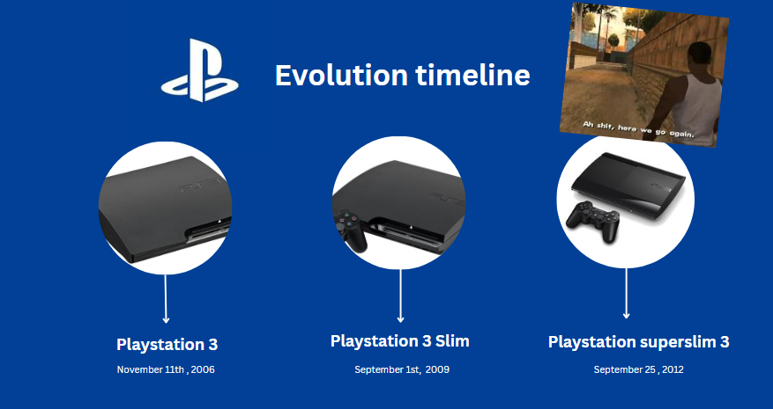

## 2.0 People who are involved in the creation of devices / OS

In order to successfully create the PS5 console, the people who are involved in the creation of the devices are very important. The creation of PS5 console involved the lead architect which is Mark Cerny, Play Station hardware engineers and designers, AMD collaboration, software development teams, game developers and studios, quality assurance and testing teams and custom silicon design teams.

Mark Cerny was born on August 24, 1964 in Berkeley, California. He started to expose himself to the journey of programming because he has shown interest in technology and video games since he was young. He’s been a programmer, producer, designer and businessman for companies including Atari, Sega and Crystal Dynamics. He has a successful career in the gaming industry in his life because of his passion and consistency towards the game development path. He works more on arcade games during his early years of his career such as “Marble Madness” and “Sonic the Hedgehog” and then he involved himself in the hardware design section of the PlayStation4 console. Due to the success of the PS4 console, Mark Cerny took the role of the lead architect again for the PlayStation5 to commit the continuity and innovation in Sony’s gaming hardware. He collab his team with AMD to design a specific component for the PS5. For instance, the console includes an octa-core AMD Ryzen Zen 2 CPU that is optimised for gaming workloads. Not only that, the GPU is also custom designed by using the AMD’s RDNA 2 architecture and the ability to support ray tracing for a better graphics rendering in PS5. Mark Cerny also included the high speed GDDR6 memory into the PS5 console to reduce the loading times and enhance the data transfer speeds. Not only that, he also worked to ensure the PS5's backward compatibility by allowing users to play games from the PlayStation 4 (PS4) on the next device. This was done to ensure a smooth transition for existing PlayStation users. In addition, he also worked on the Tempest 3D AudioTech which is a feature that delivers superior spatial audio capabilities. This technique allows gamers to play with a more immersive audio experience by providing them a greater sense of direction and depth in the sound. In conclusion, Mark Cerny plays a vital role in the creation of PS5 console’s development. His own experience and knowledge in game development and hardware design has left a huge impact A person wearing glasses and a suit
in the gaming industry and he will continue to shape the gaming experience of users in worldwide.

Mark Cerny

Up next, as the chief of the mechanical and thermal design teams, Yasuhiro Otori was contributing in the development of the PlayStation 5 (PS5) console. His contributions mostly focused on the PS5's physical design, cooling solutions and overall ergonomics. For the physical design, Otori was in charge in the managing of the PS5's console's outward appearance, form factor and aesthetics. Otori's team is responsible for the PS5's unusual design, with its aggressive and futuristic appearance. One of the challenges in building powerful game consoles is to manage the heat created by high-performance components. Otori's team focused on effective cooling methods to ensure that the PS5's operational temperatures remained optimal throughout intense gaming sessions. This is especially critical for minimising performance throttling and ensuring the hardware's lifespan. Not only that, Otori would have been engaged in defining the PS5's internal layout, including component placement to optimise the airflow and cooling efficiency. The design had to strike a balance between aesthetics and practical factors for optimal heat dissipation. In addition, Otori's staff need to choose materials that are both durable and aesthetically beautiful, as well as engineering the console to survive regular use and ensure the PS5's durability and build quality. Lastly, port location and accessibility as well as other external elements are also an important consideration in the design of any consumer electronics item. Otori's team would have supported in the decision-making process for the positioning and design of these elements on the PS5.



Yasuhiro Otori

The PlayStation hardware engineering team also plays a vital role in the creation of PS5. The PS5's proprietary memory architecture was designed and implemented by the hardware engineering team. This includes the considerations about memory type, capacity, and bandwidth, all of which are critical for supporting the high-speed data transfer necessary in gaming. They also helped to build different frequency technologies for the CPU and GPU. With the dynamic frequency adjustment, the PS5 can optimise performance based on gaming demands and improve efficiency and power utilisation. Not only that, but they also concentrated on developing a thermal design that can prevent overheating but also provides silent operation. This is critical for creating a good gaming atmosphere and it could eliminate those irritating fan noise while playing. Besides that, they also worked on implementing hardware-level security mechanisms to protect user data, prevent unauthorised access and maintain the overall security of the PlayStation 5 gaming ecosystem.

The next important role in the creation of PS5 console is the custom silicon design teams. They were critical in incorporating superior ray tracing capabilities into the custom GPU. Ray tracing improves in-game graphics realism by mimicking light behaviour and as a result it provided a more accurate reflections, shadows and lighting effects. Next, they also helped to create an efficient bus interface that ensure high-speed communication between the console's many components. This is important for reducing latency and increasing data transfer speeds. In addition, they also concentrated on improving the power efficiency of the custom silicon. As a result, it allows the PS5 to deliver great performance while balancing power consumption and heat generation at the same time. This brings up to a more long-lasting and dependable gaming experience. Not only that, but they were also involved in the development of Variable Rate Shading (VRS) technology, which allows the GPU to allocate rendering resources more efficiently. As a result, it helps to enhance graphics speed and visual quality.

Lastly, it is the PlayStation testing and quality assurance teams. The PS5 hardware components were subjected to comprehensive reliability testing by them. This involved putting the console through a series of stress tests to make sure that it could sustain extended operation under critical condition without experiencing hardware breakdowns. To guarantee the console and its components lifespan, they also in charge in examining the PS5 hardware's durability, including its capacity to tolerate physical stress and environmental condition. Not only that, the PS5 packaging design was examined by them too to ensure that the hardware is sufficiently protected to prevent console damage while shipping during the transit and distribution process. In addition, they also focus on accessibility testing to guarantee that the PS5 hardware is usable by people with a variety of needs such as includes putting voice control, screen reader compatibility and other accessibility features. Lastly, they undertook localization testing for a global audience to guarantee that the PS5 hardware could function seamlessly in diverse locations with varying languages and cultural requirements.

In conclusion, every person in the teams plays a crucial role in the creation of PS5 console. The PS5 was the result of a collaborative effort that included significant personalities such as Mark Cerny, who led the design of the hardware architecture. This concept was carried out by the PlayStation hardware engineering team, which contributed to features such as the bespoke AMD CPU and GPU, high-speed SSD, and efficient cooling solutions. The custom silicon design teams were experts in GPU architecture, advanced graphics, and power management. The PS5's dependability and durability were verified by the testing and quality assurance teams.

# 3.0 Sales & statistics about Sony’s PlayStation 5

Sony group corporation also formerly known as Tokyo Tsushin Kogyo KK, is a Japanese company headquartered in Minato, Tokyo, Japan. The Sony group corporation consists of multiple entities for example, Sony Corporation, Sony Semiconductor Solutions, Sony Entertainment (Sony Picture & Sony Music Group), Sony Interactive Entertainment, Sony Financial Group. It is a huge company with its net worth valued over 105.10 billion dollars as of 2023. A huge part of revenue earned by Sony comes from the PlayStation console which is a part of Sony Interactive Entertainment company. The massive success of the PlayStation franchise brought in a lot of revenue and introduced a lot of people into gaming. As of 2023, the latest model of PlayStation console is the PlayStation 5. PlayStation 5 is released at November 12,2020 in Australia, Japan, New Zealand, North America, South America and released worldwide after one week later. The release price for PS5 digital version costs RM 2069 and PS5 Ultra HD Blu-ray disc drive costs RM2499 which has a built-in Blu-ray disc drive. During 2020, They sold 7.8 million units, 11.5 million units in 2021, 19.1 million units in 2022. Excluding the sales in 2023, they have sold a total of 38.4 million units of PlayStation 5. The total sales of PlayStation 2 still won by a huge margin totaling 155 million units sold making it the best-selling console of all time. This year, Sony plans to release PlayStation 5 Slim but it is yet to be announced.

# 3.1 Features of PlayStation 5

The PlayStation 5 is packed fully with cutting-edge technology and new innovative features to deliver the next level of gaming to its users. One of the features of PlayStation 5 is the backwards compatibility with PlayStation 4 games. Customers can save or buy other games instead of buying the PlayStation 5 version of the same game copy. They can also download the game from PlayStation Store if users bought the digital copy instead of disc copy of it. The UI of PlayStation 5 is optimized for easy navigation and designed for better aesthetics as well. The redesigned UI offers a seamless and intuitive experience with features like Control Center to provide quick access to key functions, and the Activities feature enables players to jump into specific game levels or challenges directly from the menu. PlayStation 5 users can also cross-generation chat and multiplayer with previous PlayStation 4 users as well. New hardware technologies are implemented in the PlayStation 5, such as better graphics card (GPU) to support ray tracing which brings new levels of realism with natural shadows and reflections in games. PlayStation 5 also supports 120hz output on 4k displays which brings crispy and detailed visuals and smooth fluid motion. It is also equipped with Solid State Drive (SSD) which improves loading times which users can seamlessly navigate through the game with minimal waiting times which provides smoother and immersive experience for its user.

# 3.2 Accessories of PlayStation 5

Besides having the console, itself upon purchasing, the box includes one DualSense Wireless Controller, HDMI Cable, Power Cord, USB C cable, Stand or Base of PlayStation 5. One of the main upgrades is on the controller, which is equipped with adaptive triggers to enable users to experience varying levels of force and tension as you interact with your in-game gear and environments. The haptic feedback of the controller provides responsive feedback with dual actuators which replace traditional rumble motors and are able to simulate the feeling such as recoil of weapons. One of the examples is drawing an arrow with a bow, while stealth/action games like Deathloop which the game will physically lock the gamepad’s trigger if your gun jams in the game. Another neat controller addition is improved haptic feedback, allowing you to feel more subtle effects than simple vibration. Users can customize the looks and feel of the controller to fit their liking. You can customize controls, stick caps, and remap controls. Ergonomics is designed to feel good when gripping in order to prevent uncomfortable prolonged use.

Not only that, but there are also some accessories that are separately sold such as PlayStation VR2, Racing Wheels, Flight Stick to cater to audience that wants a more immersive experience in the virtual world, racing simulation games and flight simulation games. For a more outstanding gaming audio experience, Sony sells pulse 3D wireless headset to provide fine-tuned 3D audio with noise cancelling microphones and environment noise cancelling.

# 3.3 Fun facts about PlayStation 5

When you observe the PlayStation 5’s gamepad rear grips, you’ll see that it is covered in a textured pattern of triangles, squares, X, and circles. This is a reference of the iconic PlayStation face button symbols. During the release of the PlayStation 5, despite limited supplies caused by the ongoing industry-wide chip shortage, the PS5 shipped more consoles during its first two quarters on the market than the PS4 did during its first two quarters.

# 4.0 Hardware

## 4.1 Introduction to hardware function and capabilities

### Sony's PlayStation 5 AMD Zen 2 RDNA 2 SoC Die Shot Examined In Exacting Detail | HotHardwareCPU

Figure 1 shows PS5 CPU AMD’s Zen 2 architecture

|  |  |  |
| --- | --- | --- |
| **Component** | **Specification** | **Rating** |
| CPU | Custom AMD Zen 2 | 5/5 |
| **Description**  PlayStation 5 utilized a custom-designed CPU AMD’s Zen 2 architecture which fobbed on TSMC’s N7 node. It is a custom variant of AMD Ryzen CPU which features 8 cores and 16 threads built on the 7nm process. It integrates with memory controller optimizations and the PS5’s system architecture. | | |
| AMD’s Zen 2 architecture is regarded as a strong competitor in the CPU market which often offers immersive performance across various applications and workloads. The 7nm process which was built in with features delivers impressive performance-per-watt ratios as it helps to reduce power consumption and heat generation. This is crucial to maintain a consistent performance overall without overheating with a high core of 8 available, AMD’s Zen 2 CPU is implemented to its ability to multi-threaded workloads such as content creation, video editing, and rendering.  Zen 2 has improved its specific clock speeds which results in better-threaded performance compared to previous console models and architectures. Its architecture includes innovative features such as chipset-based design, scalability, and enhancing core counts without any redesigns.  However, some early platform and BIOS launches may cause some compatibility problems, and overclocking potential /may be limited due to some Intel counterparts. Overall, AMD’S Zen 2 has brought several advancements to the technology sector. | | |

### System memory

Figure above show single GDDR6 Module

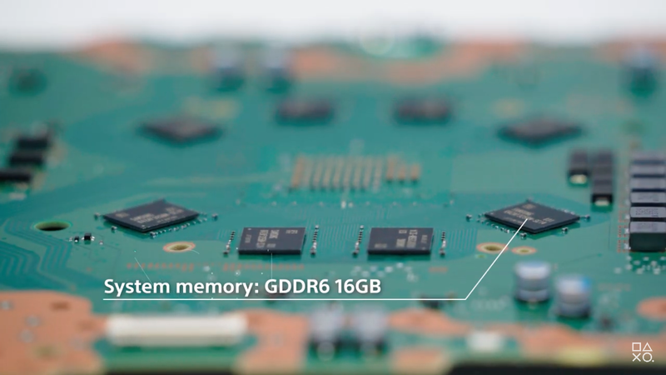

Figure above Eight 2GB GDDR6 Memory

|  |  |  |
| --- | --- | --- |
| **Component** | **Specification** | **Rating** |
| System memory | * 16GB GDDR6 Memory * Memory bus of 256 bits * Bandwidth of 448.0 GB/s | 4/5 |
| **Description**  PS5’s system memory includes advanced features that enhance gaming performance by equipping it with a customized system architecture. PS5’s console features 16GB of GDDR6 memory and the system itself boasts up to an impressive memory bandwidth of 448.0 GB/s. Speaking of system architecture, it utilizes an architecture known as unified memory that allows both CPU and GPU to access same pool of memory. Thus, allowing data access and minimizes bottlenecks between processor and graphics. | | |
| **Opinion and Advantages/Disadvantages**  With 16 GB worth of memory size, it allows for smoother performance on various occasions such as 4k smooth gaming, VR applications or complex 3d rendering. It reduces the chances of running out of memory by avoiding performance bottlenecks and ensuring the graphics card remains viable for handling upcoming software requirements. Not only that, having that substantial amount of memory available is available for storing textures, frame buffers, and other data related to high-resolution performance gaming.  However, the cost may be high as we can see from the current market trend, normally graphics card with larger memory capacities often come with a higher price tag. As for heat dissipation, greater the memory size, means more memory chips will be used and generate more heat. A cooling system has been utilized so that issue isn’t that much of a great deal. | | |

### Cooling system

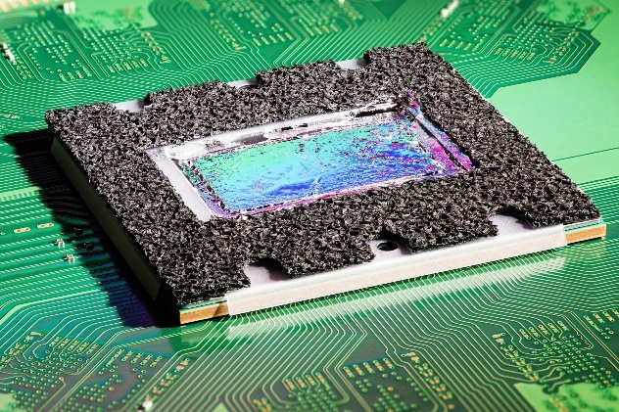

The figure above shows a cooling system of PS5

|  |  |  |
| --- | --- | --- |
| **Component** | **Specification** | **Rating** |
| Cooling system | * Liquid metal TIM * Custom heatsinks. * Dual-fan systems | 5/5 |
| **Description**  The cooling system has heat dissipation elements that are custom designed. It incorporates a large custom heatsink and copper heat pipes that aid in dissipating heat away from critical components. However, to ensure a strong connection between the chip and the heatsink, liquid metal thermal interface are used as it has better thermal conductivity compared to standard thermal pastes as it facilitates heat transfer from processor to cooling system.  Dual-fan cooling systems is a must as it manages airflow at variable speeds based on the system’s requirement with the help of adaptive control system. The system itself incorporates sensors which will monitor the temperature and adjust the speed of the fan dynamically. | | |
| **Opinion and Advantages/Disadvantages**  Advantages:  The specification that a cooling system of a PS5’s console are efficient in heat dissipation with the help of powerful processors which prevent overheating of its optimal performance. Speaking of optimal performance, proper cooling ensures components like CPU and GPU operate within safe temperature range without any throttling due to excessive number of heats. A well-designed cooling system minimize voice levels while effectively cooling the system by controlling the fan’s speed with adaptive control mechanism.  Disadvantages:  By having complex and sophisticated cooling system designs, it might increase manufacturing complexity, thus leads to increasing production cost and affect retail price of the console. Maintenance and cleaning may be needed in order to optimize performance and dust and debris might accumulated within cooling system, thus increase efficiency. Last but not least , energy consumption is taken into account as cooling systems might operate at high speed or under heavy complex loads could consume much energy and therefore affect overall power consumption. | | |

### Storage

PS5’s Solid State Drive

|  |  |  |
| --- | --- | --- |
| **Component** | **Specification** | **Rating** |
| Storage | * 852 GB custom SSD (Solid State Drive) * 5.5GB/s Read Bandwidth | 5/5 |
| **Description** | | |
| The PlayStation 5 (PS5) console includes a custom storage solution, and it is designed to provide high-speed performance, shorten the device loading times and improve the overall system responsiveness. Its primary storage solution is an 825 GB custom SSD. This SSD is a big shift compared to other gaming consoles that still using the traditional Hard Disc Drives which is HDDs. | | |
| **Opinion and Advantages/Disadvantages** | | |
| **Opinions**  The uses of Solid-State Drive (SSD) in the PS5 console are a game changing development in the console gaming market. It represents a big transition from the common Hard Disc Drives (HDDs), for example PS4 console, and it has made a huge impact in the gaming industry.  **Advantages/Disadvantages**  The first advantage of SSD is it can reduce the loading times. Faster loading times means it can give users a more seamless and immersive gaming experience without wasting unnecessary time between game levels. Next one is quick resume and multitasking. Quick resume improves the console's overall efficiency by allowing players to seamlessly switch between different gaming experiences without losing the whole progress. Not only that, but it also enhanced the system responsiveness too. It makes the non-gaming interactions smoother by providing users a friendly UI.  For its drawbacks, users may need to manage their game library more actively or invest in additional NVMe SSD storage for larger capacity. Next one is dependency on game optimization. Some games may not fully utilise the SSD's capabilities especially if they are not optimised for high-speed performance. | | |

### GPU

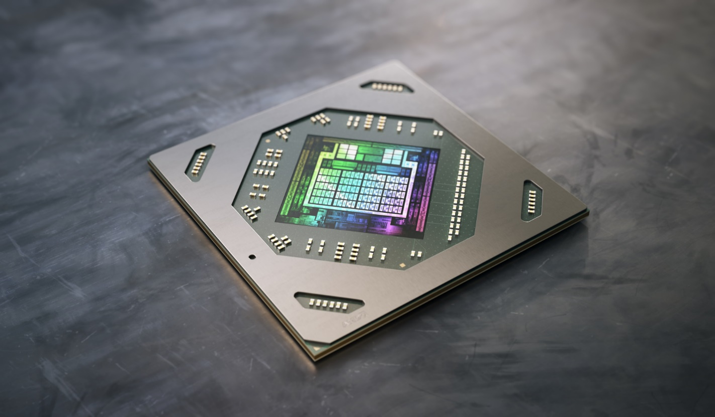

AMD Radeon RDNA 2

|  |  |  |
| --- | --- | --- |
| **Component** | **Specification** | **Rating** |
| GPU | * AMD Radeon RDNA 2 * 7 nm process size | 5/5 |
| **Description** | | |
| AMD's RDNA 2.0 architecture that includes 36 compute units are used in the PS5 console. It contains dedicated hardware for PS5 console features such as ray tracing, which improves visual realism by emulating complex lighting effects. The GPU also operates at different frequencies for a more effective performance and power management by offering high-quality visuals and supporting high resolutions and frame rates in gaming experiences. Not only that, it also can run at a variable clock speed up to 2.23GHz. | | |
| **Opinion and Advantages/Disadvantages** | | |
| **Opinion**  It is really a good component that installed inside the PS5 console because it is very good on handling games that need a high resolution and frame rates. Not only that, it also enhances the graphics quality and by using the ray tracing features to give user a more immersive experience.  **Advantages/Disadvantages**  For its advantages, this GPU contains power efficiency optimisations. It allows the console to deliver powerful performance and maintain the power usage at the same time. Not only that, it also includes the hardware accelerated ray tracing. Ray tracing could stimulate light behaviour to provide user a more realistic lightning, reflections and shadows in gaming settings. It makes user’s gaming experience more immersive.  For its drawbacks, developers may need a learning curve to fully utilise the hardware capabilities. Limited information may initially limit the development of games that take advantage of the GPU's capabilities. | | |

|  |  |  |
| --- | --- | --- |
| **Component** | **Specification** | **Rating** |
| Network Card | Sony J20H100 Wi-Fi 6 | 5/5 |
| **Description** | | |
| The PS5 has a Sony J20H100 Wi-Fi 6 network card with support for 2×2 MU-MIMO and Bluetooth 5.1. It is also backwards compatible with Wi-Fi 4. The PS5 supports both the 2.4 GHz and 5 GHz Wi-Fi bands. Real world speeds more than 300 Mbps is possible when using the Wi-Fi built into the console. This is important because it means that the PS5 will be able to take full advantage of the latest generation of online gaming and streaming services. | | |
| **Opinion and Advantages/Disadvantages** | | |
| The network card supports Wi-Fi 6 which Is the latest Wi-Fi generation which guarantees the best network bandwidth to provide a smooth and seamless experience in gaming. It enables the PlayStation 5 to be able to connect to Bluetooth 5.1 as well which is top of the line in connectivity.  The PlayStation 5 can connect wirelessly to communicate with the Internet without having to use physical connectivity such as ethernet cable thus increasing portability of the PlayStation 5. The communication speed between devices is fast and highly reliable for heavy usage such as downloading games, streaming movies or videos and much more.  There are some drawbacks to it too, wireless connections are typically less secure than wired connection because communication signals being transmitted through the air/radio waves are more likely to get intercepted if the proper encryption technologies are not in place. Wired connection is still superior to wireless connections in terms of speed and reliability. | | |

|  |  |  |
| --- | --- | --- |
| **Component** | **Specification** | **Rating** |
| Power Supply | Custom Power Supply | 5/5 |
| **Description** | | |
| The PS5 is powered by an internal power supply unit. The power supply is designed to deliver the necessary power for the console depending on the power usage. Factors such as gaming, media playback and others might influence power requirements | | |
| **Opinion and Advantages/Disadvantages** | | |
| PlayStation 5 requires electricity to run its power-hungry components. Power supplies may limit the current drawn by the load to safe levels, shutting off the current in the event of an electrical fault, power conditioning to prevent electronic noise or voltage surges on the input from reaching the load, power-factor correction, and storing energy so it can continue to power the load in the event of a temporary interruption in the source power.  In my opinion, using power supply is a safety measure to protect its user from potential hazard and keep the PlayStation safe. There isn’t a huge disadvantage in using one. | | |

## 4.2 Conclusion about the most significant components in PS5 console

Although every part of the hardware components in the PS5 console are important, but we came out with a conclusion of the most significant parts in the console which is the GPU, AMD Radeon RDNA 2.

The reason we choose the GPU as the most important part is because it in charge of the graphics rendering, assuring high quality image and deliver a smooth and engaging gaming experiences for users. The GPU is essential in the modern gaming world to perform complicated visual duties such as realistic rendering, advanced lightning effects and even faster frame rates. Not only that, but the GPU speed can also determine whether the console could bring up to a more advanced level of gaming experience or not. The importance of GPU increase since gaming develops new technologies features such as ray tracing support and 4k gaming nowadays. It is the fundamental element that results into a cinematic and real-life experience that not only fulfils but exceed gamer’s expectation.

Overall, the GPU is essential in the PS5 console in order to transform gaming into a more immersive and visually stunning experience for gamers.

# 5.0 Operating System

## 5.1 Introduction

The PlayStation 5 (PS5), which sports an advanced distinctive operating system called Orbis OS, is considered the height of technical sophistication. This cutting-edge platform is expertly built on the strong foundation of the FreeBSD operating system, a highly regarded Unix-like OS that is well-known for its unmatched reliability, strong performance and complex networking features. The deliberate selection of FreeBSD as the foundational operating system not only highlights Sony’s dedication to dependability but also capitalizes on the OS’s open-source character, in-line with the configuration and flexibility requirements that are fundamental to an innovative gaming console.

The enhanced version of the Orbis OS is more than just a development, it is a system built to maximize the capabilities of PlayStation 5’s unique hardware architecture. This requires extensive optimization to ensure that the console’s CPU, GPU and other specialized components are used efficiently. As the central component, the kernel controls key activities like process scheduling, memory allocation and device driver management, all of which contribute to the system’s overall stability and performance.

Apart from that, the customized Orbis OS has various new functions that improve the user experience. Users may smoothly change between various running programs thanks to fast game switching features, emphasizing the smoothness of the gaming experience. A notable feature is “Activities”, which gives in-game suggestions, tips and shortcuts, expanding gameplay without requiring the user to leave the current gaming session. Furthermore, the Game Help function provides contextual advice to gamers, making the gaming experience more immersive and supportive.

## 5.2 User Interface

The PlayStation 5 (PS5) user interface is a powerful and user-centric digital environment that has been thoroughly developed to improve the entire gaming and entertainment experience. The PS5 user interface, with its dynamic and visually appealing design, offers users straightforward access via the Home Screen, Control Centre and Game Library. The interface provides a smooth combination of accessibility and customization, with rapid access to regularly played games, media apps and configurable places. The Activities, Switcher and Game Hub features add to the interface’s engaging and integrated character, highlighting Sony’s dedication to developing a complete and simple to operate gaming environment.

First and foremost, the Control Centre is a major part of the PS5 UI. The Control Centre functions as an integrative overlay menu intended for easy and smooth user interaction. It is opened by holding the PlayStation button on the controller and provides a pleasant interface that allows users to continue with their present activity while quickly exploring critical functions. Amongst its features is instant accessibility to audio settings, which allows users to modify the volume and audio settings instantaneously. Notifications are minimized inside the UI to keep consumers updated while not interfering with their gaming experience. Furthermore, the Control Centre makes it simple to handle friends and party invitations, promoting a sense of social connectedness. Music controls enable you to take control of the music in the background without having to abandon the present game or program.

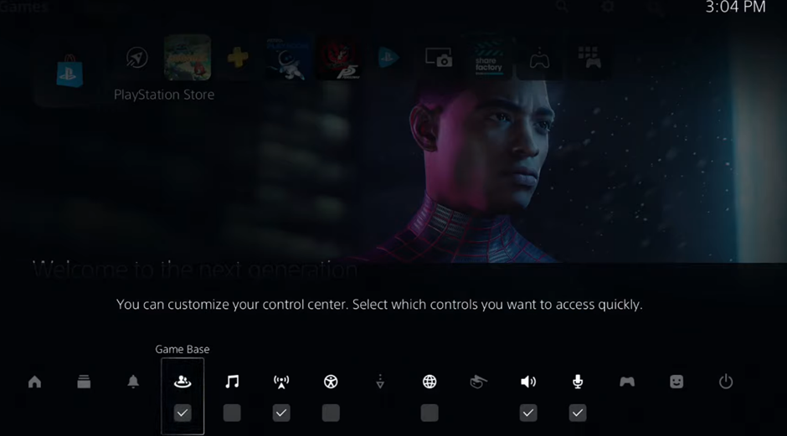

Diagram shows a picture part of the PS5’s Control Centre.

In addition, Quick Settings accelerate the user experience by providing quick access to basic system features such as power options and network settings. Sony’s dedication to inclusiveness is made clear by the inclusion of accessibility tools, which allow users to quickly customize settings for improvised use. The Game Switcher function allows users to move among various running programs or games, improving the ability to multitask. The Control Centre also displays systems information, giving users a detailed picture of the console’s state, including battery levels for linked controllers. In a nutshell, the Control Centre exhibits user-oriented design, easing user interaction and leading to an enhanced PlayStation 5 gaming experience.

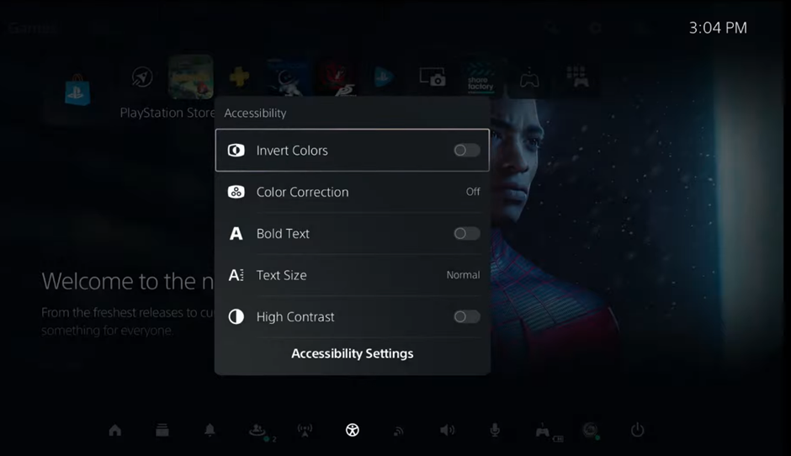

Diagram shows a picture part of the PS5’s Quick Settings.

The PlayStation 5 (PS5) user interface heavily relies on the implementation of Graphical User Interface. The Home Screen and Dashboard, which greets users with a graphically lively interface upon launch, are at the core of the PS5 graphical user interface. The Dashboard displays a grid of huge tiles that highlights previously played games, media apps and other related material. Icons play an important part in this graphical environment, displaying games, programs and system elements with precision and uniformity. Several visual features, such s buttons and menus, help to a visually beautiful and practical experience by easily leading users along the interface. Besides that, the GUI adds customizable places to the Home Screen, enabling users to organize and bookmark their favorite games and programs, improving both visual flexibility and personalized interaction.

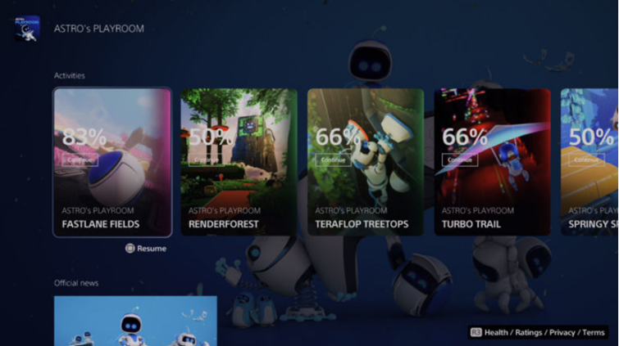

Diagram shows part of the PS5’s home screen.

## 5.3 File management operating system

An essential component of every operating system is the file system. They give users access to data, let them upload and store information, and extend the functional life of hard disks. Historically, the Unix File System (UFS), which has been updated to UFS2, has been the native file system for FreeBSD. Z File System (ZFS) is also accessible as a native file system since FreeBSD 7.0. What is ZFS? ZFS is a local file system and logical volume manager, to guide and regulate the arrangement, storage, and retrieval of data in enterprise-class computer systems. ZFS is designed to run on a single server with hundreds, if not thousands, of storage drives attached. ZFS pools available storage and manages all disks as a single unit. If the file system requires additional space, users can add storage drives to the pool. ZFS is highly scalable and supports large maximum file sizes.

The Figure above shows about ZFS file system

**ZFS has three major design goals:**

1. **Data integrity**

* ZFS-based systems are designed to protect data from silent data corruption caused by parity errors, accidental overwrites, disk firmware errors, phantom writes, driver errors, and more. (rho, 2023)
* This special file system ensures that checksums are always written to disk. (rho, 2023)
* This information is recalculated when the data is read again. If a checksum mismatch is detected, an attempt is made to correct the error if data redundancy exists. This process happens automatically and without your knowledge. (rho, 2023)

1. **Pooled storage**

* A group of one or more virtual devices, or vdevs, that present to the file system as a single storage device is called a ZFS pool (Zpool). (rho, 2023)

1. **Performance**

* Caching systems offer better performance. An improved memory-based read cache is called Adaptive Replacement Cache (ARC).
* ZFS offers a disk-based synchronous write cache called ZIL as well as a second level disk-based read cache called level 2 Adaptive Replacement Cache (L2ARC).

ZFS, whenever data is written to disk, the system stores at least two copies of metadata. This metadata contains details like the disk sector where the data is located, the size of the data block, and a binary checksum of the data. When a user wants to access a file, a checksum algorithm is used to verify that the retrieved data matches the original bits written to the disk. This helps ensure data integrity and accuracy during access. If the checksums detect a mismatch, bad data is flagged. On systems with mirrored storage pools or ZFS RAID versions, ZFS can retrieve the correct copy from other drives and repair corrupted data copies. ZFS is often known as a copy-on-write file system. Unlike traditional methods where data overwrites existing information, when ZFS writes data to disk, it doesn't directly overwrite the existing data. Instead, ZFS writes the new data block to a different location on the disk and updates the metadata to reference this newly written block. Meanwhile, it retains the old version of the data intact.

In essence, ZFS stands out from traditional file systems by combining the functions of a volume manager and a file system. This integration offers ZFS a notable advantage. Unlike traditional systems that typically operate on a single disk at a time, with each disk requiring its own file system, ZFS can manage multiple disks within a single file system. This means that even when using multiple disks, ZFS doesn't necessitate creating separate file systems for each individual disk. By giving the operating system a single logical drive comprised of the space given by physical disks, over which the operating system arranged a file system, a classic hardware RAID arrangement circumvented this issue. The UFS file system, when operating on top of a RAID setup, perceives and interacts with the system as if it were dealing with a single device. This holds true even in scenarios where software RAID solutions, such as those provided by GEOM, are employed. The advantage of ZFS files is the awareness of the physical disk layout in that system grow automatically. This will create a new space in the file system. ZFS files also can add different properties to each of the file system. This will be helpful to produce separate files system and datasets rather than single monolithic file system.

# 5.4 SECURITY AND PROTECTION SERVICES

Security is a shared responsibility for each and every individual. A vulnerable entry point within any system could allow unauthorized access to important information which may lead to disruptions on an entire network. In the constantly changing world of gaming, the PlayStation 5 (PS5) gives a huge importance when it comes to security and data protection of its users. Therefore, The PS5 idealizes a gaming environment where the users confidently trust their data to be handled securely while their gaming experiences and connection to the virtual world remains persistent. By implementing an in-depth defence strategy guided by primary principles of security which is Confidentiality, Integrity, and Availability, the PS5 goes beyond traditional security measures, acknowledging the complex and diverse nature of potential threats. In this exploration of security and protection services for the PS5, we unveil how the console ensures a captivating gaming experience while facilitating an environment that builds confidence in the security, accessibility, and confidentiality of users' gaming data. (Pronchery, 2023)

The first security measure that has been integrated for securing the PlayStation 5 (PS5) is consideration of user authentication and authorization systems which is a critical aspect in safeguarding access to the console's operating system. The authentication process involves diverse methods which primarily rely on secure passwords. This password-based identification requires its users to create a unique login username and a strong password for their account. (Sultan, 2023) While this method is effective in enhancing security, it is crucial to recognize potential challenges, including the risk of dictionary attacks or social engineering. To enhance security, encrypted connections are important to prevent the transmission of plain-text passwords over the network. Additionally, established systems like Kerberos, utilizing symmetric encryption and encrypted tickets, further contribute to a comprehensive security strategy. The PS5's security considerations extend beyond the console to services like FTP and distributed file systems, highlighting the importance of authentication protocols and access rights management. (Persson, n.d.)



Figure Alert Mail (Rinchumrus, 2023)

Besides user authentication and authorization, the FreeBSD operating system also implies Intrusion Detection System (IDS) to enhance its security and protection services. What is Intrusion Detection System? An intrusion detection system (IDS) is a mechanism that monitors network traffic, identifies potential harmful transactions and issues alerts instantly upon detection of any malicious activity. (Intrusion Detection System (IDS), 2023) This software is designed to look over networks or systems for any signs of malicious activities or violations of the established policies. Therefore, the IDS generates alerts and notifications such as warning emails to notify the system administrators if there are any changes detected in the system. This reporting mechanism ensures that administrators are always informed of any suspicious activities and enables them to investigate and rectify any sorts of potential security breaches within a short period of time. (Pronchery, 2023)

Last but not least, handling system resources efficiently is one of the major aspects taken into consideration when it comes down to the security of the PlayStation 5, thanks to resource limit mechanisms in FreeBSD. The aim of this mechanism is to overlook the distribution of the system’s resources among its processers and users. This ensures that no individual element can dominate the resources excessively to avoid any negative impacts that can affect the system’s performance or stability. Thus, FreeBSD offers various ways for an administrator to control how much system resources an individual can utilize. (Pronchery, 2023)

# 6.0 Conclusion

The PlayStation 5 is an advanced gaming console with the combination of advanced hardware integration and a complex operating system. However, the developers have made it possible for the users to have a really enjoyable experience gaming with the PS5 as it offers smooth and easy navigation.

The AMD Radeon RDNA 2 GPU is the most significant part in the PS5 hardware, ensuring excellent visuals and seamless gameplay while also enabling advanced capabilities such as ray tracing and 4k gaming. Its functionality is critical in providing an immersive and visually appealing gaming experience that exceeds player expectation.

The PS5 has the modern Orbis OS, which is based on FreeBSD and demonstrates Sony's dedication to dependability. With rapid game switching, Activities and Game Help for an immersive gaming experience, the optimized OS maximized the hardware’s potential. The PS5 interface has been deliberately designed to provide a smooth gaming experience. Important attributes such as the Control Centre and customizable Home Screen demonstrate Sony’s attention to user-friendly design, improving social connectivity and accessibility for an enhanced gaming experience.

On the other hand, ZFS is a strong FreeBSD file system with crucial characteristics such as data integrity, shared storage and better speed. Its one-of-a-kind architecture, which combines volume management with the file system functions, allows for dynamic space allocation and the establishment of different file systems. ZFS provides a reliable option for large-scale storage infrastructures.

Furthermore, the PlayStation 5 also strongly prioritizes security for its user and the operating system by safeguarding user data within the evolving gaming environment. While focusing on Confidentiality, Integrity, and Availability as their principles, the PS5 incorporates strong authentication and authorization systems to encourage its users to create unique and distinctive login credentials. Besides that, the FreeBSD operating system integrates an Intrusion Detection System (IDS) for real-time monitoring and creates alerts rapidly to any potential threats. Additionally, the inclusion of resource limit mechanisms prevents any single element from excessively dominating resources to ensure the stability and security of the system. These layers of protection and services show the PS5's commitment to delivering a secure and fascinating gaming experience to the users.

# 7.0 References

1. Staff, G., Wilson, T., & Blumenthal, M. (2020, November 12). Everything you need to know about the PS5. *GameSpot*. <https://www.gamespot.com/articles/everything-you-need-to-know-about-the-ps5/1100-6466357/>
2. Karanjkar, K. (2023, May 11). *Sony | History | Products | Facts*. https://www.linkedin.com/pulse/sony-history-products-facts-kiran-karanjkar
3. *History of Sony Game Consoles Timeline | Preceden*. (n.d.). https://www.preceden.com/timelines/484018-history-of-sony-game-consoles
4. Anyfantis, A. (2023, December 9). *A brief history of the PlayStation*. SUPERJUMP. https://www.superjumpmagazine.com/a-brief-history-of-the-playstation/
5. Diaz, A. (2021, November 19). PS5 architect Mark Cerny on game developers influencing hardware design. *Polygon*. https://www.polygon.com/22792063/ps5-design-sony-mark-cerny-game-developers
6. OpenAI. (2023). ChatGPT (Feb 13 version) [Large language model].
7. *Sony Reveals PS5 Hardware: RDNA2 Raytracing, 16 GB GDDR6, 6 GB/s SSD, 2304 GPU Cores*. (n.d.). TechPowerUp. https://www.techpowerup.com/264881/sony-reveals-ps5-hardware-rdna2-raytracing-16-gb-gddr6-6-gb-s-ssd-2304-gpu-cores?cp=2
8. Orry, T. (2020, November 6). PS5 review: The joy of discovery and a real feel of next-gen. *VG247*. https://www.vg247.com/ps5-review-next-gen-playstation
9. Cangemi, D. (2021, December 16). Walking through the PlayStation 5 user interface - SUPERJUMP - Medium. *Medium*. https://medium.com/super-jump/sony-unveils-the-playstation-5-user-interface-and-its-awesome-588ff13933c4
10. Digital Horizon. (2020, November 19). *How to customize the PS5 Control Center (Quick menu)* [Video]. YouTube. <https://www.youtube.com/watch?v=po8DHwnXLko>
11. *Chapter 22. The Z File System (ZFS)*. (n.d.). FreeBSD Documentation Portal. https://docs.freebsd.org/en/books/handbook/zfs/

# 8.0 Appendices

## 8.1 Work breakdown structure

|  |  |  |
| --- | --- | --- |
| **Students** | **Allocation of work** | **Signature** |
| Tsang Da Xin | * Introduction to operating/system * Evolution time diagram * CPU - Custom AMD Zen 2  * System memory - 16GB of GDDR6 * Cooling system * Conclusion on the most significant hardware components for the PS5 console * Frequently asked questions * Abstract |  |
| Tan Yen Hau | * Sales and statistics of PS5 (3.0 – 3.2) * Power Supply – Custom PSU * Network Card - Sony J20H100 Wi-Fi 6 * Conclusion on the most significant hardware components for PS5 console * Frequently asked questions |  |
| Patrick Woo Soon Tat | * People who involved in the creation of PS5 console * Storage – 852GB Solid State Drive (SSD) * GPU – AMD Radeon RDNA 2 * Conclusion on the most significant hardware components for PS5 console * Frequently asked questions |  |
| Vasshan Raj A/L Ganesan | * Introduction to the Operating System of the PS5 * User Interface of PS5 * Secretary * Preparing Minutes of Meeting * Formatting * Conclusion |  |
| Ebenezer Paul A/L Vilsan Paul | * File management * Gantt chart |  |
| Anantha Krisnan A/L Thiru Kumar | * Security and protection services of the PS5 * Abstract * Conclusion |  |

# 8.2 Minutes of Meeting

|  |  |
| --- | --- |
| **Date** | 1st November 2023 |
| **Call to order** | The meeting of this OSCA assignment group was held at classroom B-6-8 on 1st November 2023 |
| **Attendees** | Vasshan Raj, Tsang Da Xin, Tan Yen Hau, Anantha Krishna, Patrick Woo Soon Tat, Ebenezer Paul. |
| **Discussions** | Decided on assignment topic. |
| **Unfinished Business** | Creating a google document to input assignment. |
| **New Business** | Task division between group members |
| **Announcements** | Hardware: Tsang Da Xin, Tan Yen Hau, Patrick Woo Soon Tat  Software: Vasshan Raj, Anantha Krishna, Ebenezer Paul |

Secretary: Vasshan Raj

Date of Approval: 1st November 2023

|  |  |
| --- | --- |
| **Date** | 1st December 2023 |
| **Call to order** | The meeting of this OSCA assignment group was held at Tech Lab 4-05. |
| **Attendees** | Vasshan Raj, Tsang Da Xin, Tan Yen Hau, Anantha Krishna, Patrick Woo Soon Tat, Ebenezer Paul. |
| **Discussions** | Update check on progress. |
| **Unfinished Business** | Combining work into the main google document. |
| **New Business** | Complete tasks given. |
| **Announcements** | Create a layout in the google document to put in our work. |

Secretary: Vasshan Raj

Date of Approval: 1st December 2023

|  |  |
| --- | --- |
| **Date** | 16th December 2023 |
| **Call to order** | The meeting of this OSCA assignment group was held online on Microsoft Teams. |
| **Attendees** | Vasshan Raj, Tsang Da Xin, Tan Yen Hau, Anantha Krishna, Patrick Woo Soon Tat |
| **Discussions** | Update check on progress. Discussed what more is possible to be added. |
| **Unfinished Business** | Formatting the google document. |
| **New Business** | Making the final touches to complete the assignment. |
| **Announcements** | Finish everything needed by 17th December 2023 |

Secretary: Vasshan Raj

Date of Approval: 16th December 2023

|  |  |
| --- | --- |
| **Date** | 17th December 2023 |
| **Call to order** | The meeting of this OSCA assignment group was held online on Microsoft Teams. |
| **Attendees** | Vasshan Raj, Tsang Da Xin, Tan Yen Hau, Anantha Krishna, Patrick Woo Soon Tat, Ebenezer Paul. |
| **Discussions** | Doing an overall review upon our assignment. Checking for errors and incomplete parts. |
| **Unfinished Business** | Check for plagiarism. |
| **New Business** | Submitting the file in Turnitin for similarity report. |
| **Announcements** | Assignment will be submitted on 18th December 2023 |

Secretary: Vasshan Raj

Date of Approval: 17th December 2023

# 8.3 Frequently asked question

**1. What is the difference between the PS5 console and the PS5 Digital Edition console?**

The difference between the PS5 vs the PS5 digital edition is if it has a ultra HD Blu-ray disc drive in the console. The PS5 Digital Edition console does not have one.

**2. What is special about PS5’s SSD?**

PS5’s ultra-high-speed SSD is to remove loading screen times. Developers can stream assets into PS5 games very quickly. With the enhanced speed of the SSD, this enables game developers to create larger, richer worlds without limitations like a HDD with slow load times and it allows users to spend more time gaming than waiting.

**3. What input/output ports and connectivity features does PS5 support?**

* Front I/O: 1x USB Type-C port, 1x USB Type-A port
* Back I/O: 2x USB Type-A port, HDMI port, LAN port

**4. Does PS5 use an external power brick?**

No, PS5 has a bulit in power brick.

**5. What is included in the PS5 box at launch?**

Depending on the model you purchase, it’ll include

* The PS5 console or PS5 Digital Edition console
* 1x DualSense wireless controller
* USB Type-C to Type A charging cable for the controller
* HDMI cable
* AC power cord
* PS5 base
* Quick start and safety guide

**6. Does PS5 support backward compatibility for games?**

The PS5 console is backwards compatible with most PS4 games. This means previous PS4 console & games owner can transfer their data to PS5.

**7.How to manage PS5 consoles storage?**

Most of the data (game data) is stored on the built in storage on your PS5 console. If you don't enough storage on your PS5, try to delete or move your data to one of the following storage spaces:

* USB extended storage
* M.2 SSD storage
* Cloud storage
* USB drive

**8. How to download PlayStation games remotely?**

Games purchased can be download remotely via a web browser or Play Station App. To start remote downloading , you’ll need to set up automatic downloads in the settings.

**9. How to voice chat with Discord on PS5 consoles?**

To use Discord on the PS5, you must link your PS Network account to your Discord account.

1. Open the Discord app on your device then log in to your account, after that you can start or join a voice channel.
2. Select the option to join on PlayStation, and then select your PS5 console* from the list that appears.
3. When your PS5 has successfully connected to the voice channel, a notification will pop up on your screen.
4. Select the “view Discord voice chat” from the notification of the PS5 to open the Discord voice chat card.

**10. How to set up PS5 console for remote play?**

You’ll only need to perform this once

1. From the home screen, select Settings à System à Remote Play à Enable Remote Play.
2. To start remote play when your PS5 is in rest mode go to Settings à System à Power Saving à Features Available in rest mode. Lastly, enable “Stay Connected to the Internet and Enable”

# 8.4 Gantt chart

